**Lab 1**

Question no.1:

1. **(A.B.C).(A+B+C)**

**TRUTH TABLE:**

|  |  |  |  |  |  |
| --- | --- | --- | --- | --- | --- |
| **A** | **B** | **C** | **A.B.C** | **A+B+C** | **F** |
| 0 | 0 | 0 | 0 | 0 | **0** |
| 0 | 0 | 1 | 0 | 1 | **0** |
| 0 | 1 | 0 | 0 | 1 | **0** |
| 0 | 1 | 1 | 0 | 1 | **0** |
| 1 | 0 | 0 | 0 | 1 | **0** |
| 1 | 0 | 1 | 0 | 1 | **0** |
| 1 | 1 | 0 | 0 | 1 | **0** |
| 1 | 1 | 1 | 1 | 1 | **1** |

**CIRCUIT:**

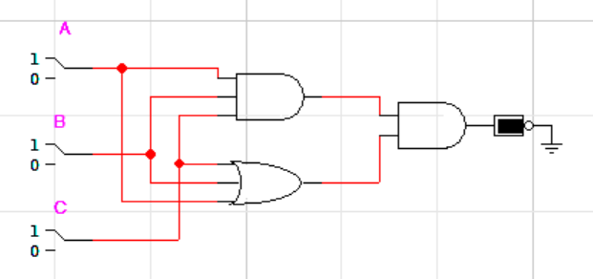

1. **BC'D'+A'B'CD'+ABD'**

**TRUTH TABLE:**

|  |  |  |  |  |  |  |  |  |  |  |  |
| --- | --- | --- | --- | --- | --- | --- | --- | --- | --- | --- | --- |
| **A** | **B** | **C** | **D** | **A’** | **B’** | **C’** | **D’** | **BC’D** | **A’B’CD’** | **ABD’** | **F** |
| 0 | 0 | 0 | 0 | 1 | 1 | 1 | 1 | 0 | 0 | 0 | **0** |
| 0 | 0 | 0 | 1 | 1 | 1 | 1 | 0 | 0 | 0 | 0 | **0** |
| 0 | 0 | 1 | 0 | 1 | 1 | 0 | 1 | 0 | 1 | 0 | **1** |
| 0 | 0 | 1 | 1 | 1 | 1 | 0 | 0 | 0 | 0 | 0 | **0** |
| 0 | 1 | 0 | 0 | 1 | 0 | 1 | 1 | 0 | 0 | 0 | **0** |
| 0 | 1 | 0 | 1 | 1 | 0 | 1 | 0 | 1 | 0 | 0 | **1** |
| 0 | 1 | 1 | 0 | 1 | 0 | 0 | 1 | 0 | 0 | 0 | **0** |
| 0 | 1 | 1 | 1 | 1 | 0 | 0 | 0 | 0 | 0 | 0 | **0** |
| 1 | 0 | 0 | 0 | 0 | 1 | 1 | 1 | 0 | 0 | 0 | **0** |
| 1 | 0 | 0 | 1 | 0 | 1 | 1 | 0 | 0 | 0 | 0 | **0** |
| 1 | 0 | 1 | 0 | 0 | 1 | 0 | 1 | 0 | 0 | 0 | **0** |
| 1 | 0 | 1 | 1 | 0 | 1 | 0 | 0 | 0 | 0 | 0 | **0** |
| 1 | 1 | 0 | 0 | 0 | 0 | 1 | 1 | 0 | 0 | 1 | **1** |
| 1 | 1 | 0 | 1 | 0 | 0 | 1 | 0 | 1 | 0 | 0 | **1** |
| 1 | 1 | 1 | 0 | 0 | 0 | 0 | 1 | 0 | 0 | 1 | **1** |
| 1 | 1 | 1 | 1 | 0 | 0 | 0 | 0 | 0 | 0 | 0 | **0** |

**CIRCUIT:**

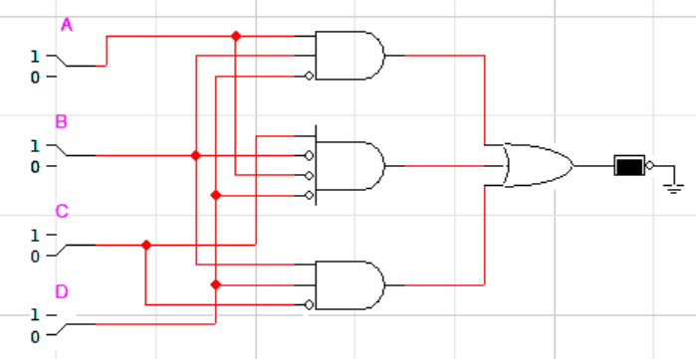

Question no. 2:

1. **(A.B.C)+(A+B+C)**

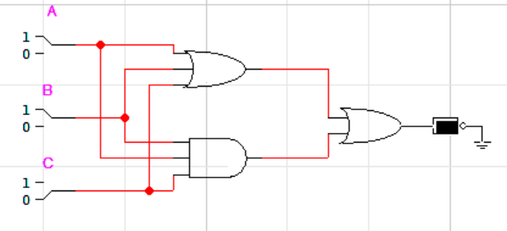

1. **(A.B.C).(A+B+C)**



1. **BC'D'+A'B'CD'+ABD'**



Question no. 3:

**F2 = [(A+BC’).(A’C’)]’+ C**

**TRUTH TABLE:**

|  |  |  |  |  |  |  |  |
| --- | --- | --- | --- | --- | --- | --- | --- |
| **A** | **B** | **C** | **A’** | **C’** | **A+BC’** | **A’C’** | **F2** |
| 0 | 0 | 0 | 1 | 1 | 0 | 1 | **0** |
| 0 | 0 | 1 | 1 | 0 | 0 | 0 | **1** |
| 0 | 1 | 0 | 1 | 1 | 1 | 1 | **1** |
| 0 | 1 | 1 | 1 | 0 | 0 | 0 | **1** |
| 1 | 0 | 0 | 0 | 1 | 1 | 0 | **0** |
| 1 | 0 | 1 | 0 | 0 | 1 | 0 | **1** |
| 1 | 1 | 0 | 0 | 1 | 1 | 0 | **0** |
| 1 | 1 | 1 | 0 | 0 | 1 | 0 | **1** |

**CIRCUIT:**

